Major Histocompatibility Complex
These are tight cluster of genes present in every mammalian species. The products of these MHC genes play a major role in intercellular recognition and in discriminating between self and non-self. They participate in both Humoral and cell mediated Immune responses. Most T-cells recognize Ag only when it is associated with MH molecules. They act as Ag presenting structures. Based upon the set of MHC molecules presenting Ag, the T-cells are grouped into T c cells and T_{H} cells.
General organization and inheritance of MHC:
The major histocompatibility complex is a collection of genes present as a continuous stretch of DNA on chromosome 6 of human and chromosome 17 of mice. In human the MHC is called HLA complex where as in mice it is called H-2 complex. These genes encode for 3classes of molecules.
- Class I MHC genes: These encode for glycoproteins and ae expressed on almost all nucleated cells. Their products present peptide Ag’s to Tc cells.
- Class II genes: These encode glycoproteins expressed on Antigen Presenting cells (Macrophages, dendritic cells and B-cells), and they present processed peptide Ag’s to T_{H} cells.
- Class III MHC genes: These encode for other proteins which are secreted out. They are mostly complement proteins and molecules involved in inflammatory responses.
For us the important genes are MHC class I and HC class II genes. The MHC genes are linked together and the genes inherited by a person form one parent in known as Haplotype.
HLA gene products: In human HLA gene products are A, B and C which expresses the products HLA-A, HLA-B and HLA-C molecules. These are also known as classical class I molecules. They are expressed on to the cell surface along with β₂-microblobulin molecules, which inturn is a protein expressed by genes outside MHC.
The products of MHC Class II genes are HLA-DP, HLA-DQ and HLA-DR which are encoded by DP, DQ and DR genes respectively. Each of these genes inturn has A and B regions which encode for α and β chains respectively. An α-chain always combines with that particular β−chain only. Eg; DP α-chain always pairs with DP β-chain. The genes coding for DP α-chain are known as DPA1 and those for DPβ chain are known as DPB1. Similarly genes coding for DQα and DP β are known as DQA1 and DQB1 respectively. Similarly genes coding for DQα and DQβ are known as DQA1 and DQB1 respectively.
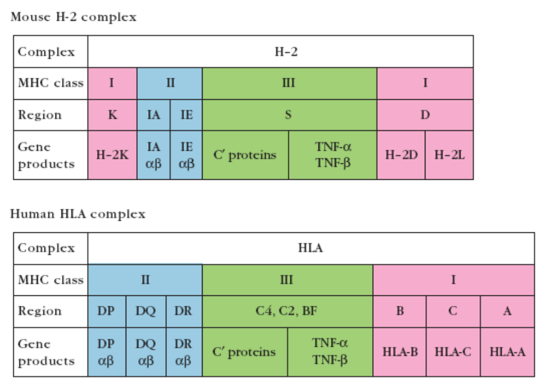

Mouse H-2 complex: Mouse MHC class I products are H-2K, H-2D and H-2L, and are expressed onto the cell surface with β₂-microglobulin. MHC class II molecules are I-Aα β and I-E α β synthesized by I-A and I-E regions. The genes are referred to as H-2I-Aa and H-2I-Ea and H-2I-Eb. The a and b genes express α and β chains which pair up and are expressed on cell surface.

Genetic polymorphism of MHC: MHC is said to be highly polymorphic. There are multiple alleles present at a specific gene locus. The alleles are- alternative forms of a gene. The genes of MHC lie close to each other, therefore the chances of recombination are very less (may be 1 in every 200 mitotic cycles. Therefore each individual will receive two sets of gene loci from each parent. Each set of alleles is called haplotype.
These alleles are codominantly expressed, therefore both maternal and paternal gene products are expressed on all the cells. This is under heterozygous conditions. The off springs can accept grafts from both the parents but the parents cannot accept grafts from their children as half of the childrens grafts Ag’s are nonself, hence it will be rejected.
In case of mice which are inbred- identical at both the loci, the maternal and paternal haplotypes are identical and all offsprings express identical haplotypes. They can exchange grafts. While outbred strains are again heterogenous.
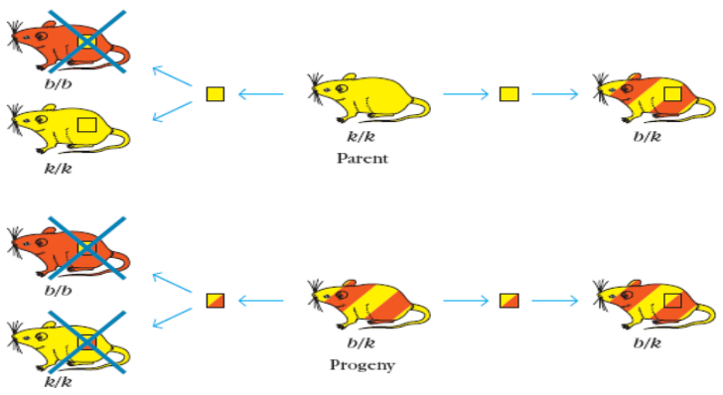

In human the HLA is polymorphic. If mother and father have different haplotypes, there is one in four chances that the siblings inherit the same paternal and maternal haplotypes and therefore be histocompatible with each other. But none of the F1 are histocompatible with the parents.
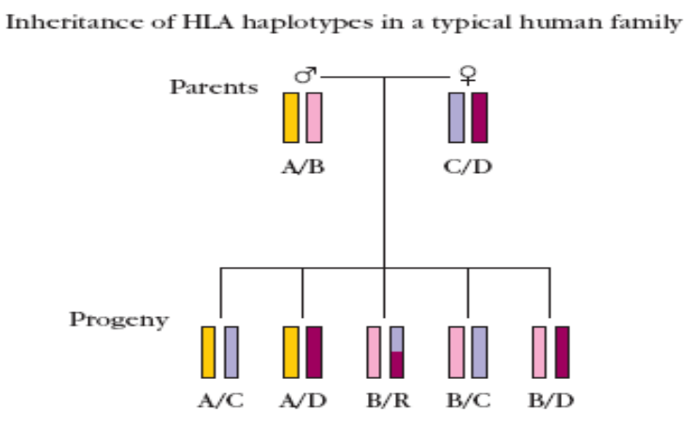

Structure of MHC molecules:
MHC class I : these consists of an α−chain which is organized into 3 domains- α1, α2 and α3. A small β₂-microglobulin molecule is found associated with it non-covalently.
α-chain is a glycoprotein: Encoded by A,B and C regions of HLA complex.
-anchored to plasma membrane by a transmembrane segment which is hydrophobic.
β₂-microglobulin: It does not have a transmembrane segment. It is not expressed by genes of HLA. It pairs with α3 domain. It also interacts with α1and α2 domain.
The α1and α2 domains interact to form a deep groove or cleft called peptide binding cleft. It can accommodate 8-10 aminoacids.
MHC class II: it consists of two different polypeptides α and β which are associated by non-covalent interaction. Each polypeptide has two domains, α1, α2 and β1, β2. hence it is also known as dimmer of dimmers. The α2 and β2 have structural similarities to Ig. α1 and β1 form the peptide binding cleft.
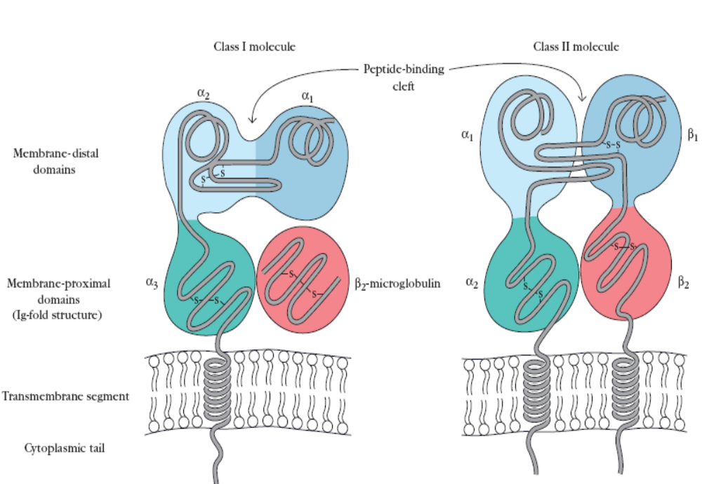

Polymorphism of MHC class I and Class II molecules: Several hundreds of different allelic variants were identified in human for MHC class I and class II molecules. In an individual, 6 different class I molecules and upto 12 different class II molecules exist. The peptide binding cleft deos not exhibit specificity as Ig and TCR. It can bind to numerous peptides. Hence it is refereed to as Promiscous.
Cellular distribution of MHC molecules:
MHC ClassI: MHC class I is exhibited on almost all nucleated cells. In lymphocytes, they constitute to the maximum of 1% of the plasma-membrane protein approximately 5 x 10⁵ molecules/cell. Lowest is found in liver cells, hence there are successfully transplanted. Few cells like neurons and sperm cells lack this MHC hence they are not rejected. In normal individuals, MHC will express self-peptides formed as a result of normal protein degradation. In case of virally infected cells, the cells express several kinds of viral peptides on the different MHC class I molecules present on their surface.
MHC class II molecules: These are expressed by APC’s, primarily dendritic cells, Macrophages, Bcells and thymic epithelial cells. Their expression is increased under the stimulation of cytokines.
Eg: Pre-B cells lack them, but present immature B cells. Even Monocytes and macrophages have very low levels of MHC. Interaction with Ag, increases their expression.

Important questions: Write a brief account on HLA molecules and add a note on the structure of Class I and Class II molecules structure.

